**-:Experiment No 12:**

**(**Mini Project**)**

**Aim:- Mini Project**

**Lab Outcome:- ITCL.7.1.1,To Implement Basic Graphics Primitives.**

**ITCL7.1.2, To Implement Viewing,Filling,Clipping and Transformation algorithm and develop Animation.**

**ITCL 7.1.3,Use and Explore different Virtual Reality Toolkit**

**Theory:-**

**VRML:-**

VRML (Virtual Reality Modeling Language) is a language for describing three-dimensional ( [3-D](http://whatis.techtarget.com/definition/3-D-three-dimensions-or-three-dimensional) ) image sequences and possible user interactions to go with them. Using VRML, you can build a sequence of visual images into Web settings with which a user can interact by viewing, moving, rotating, and otherwise interacting with an apparently 3-D scene. For example, you can view a room and use controls to move the room as you would experience it if you were walking through it in real space.

To view a VRML file, you need a VRML viewer or browser, which can be a [plug-in](http://searchcio-midmarket.techtarget.com/definition/plug-in) for a Web browser you already have.In Our Case we had used Cortona 3D Viewer plugin for our Project that was **TO DISPLAY BASIC GRAPHIC PRIMITIVES (SHAPES)** Like Line,cylinder,Cone,Cube and Circle**.** Among viewers you can download for the Windows platforms are blaxxun's CC Pro, Platinum's Cosmo Player, WebFX, WorldView, and Fountain. Whurlwind and Voyager are two viewers for the Mac.A VRML Header File is mandatory as it converts the plain text mode to 3D Graphics mode by indicating “#” before VRML, it is actually **#VRML V2.0 utf8.**

So all the shapes mentioned above were displayed according to each and every parameter.For Example Circle, So only one parameter **RADIUS.** For Cone ,**HEIGHT** and **BOTTOMRADIUS** etc.For VRML,we use text editors like VRMLpad or even a simple Notepad had helped us and then we save it by **.wrl** or **.vrml**

**-Source Code:-**

#VRML V2.0 utf8

Transform{

translation 5.5 0.3 0

children[

Shape {

appearance Appearance {

material Material { diffuseColor 1 1 0 }}

geometry Sphere{ radius 1 }}]}

Transform{

rotation 1 0 0 47

children[

Shape {

appearance Appearance {

material Material { diffuseColor 1 0 0 }}

geometry Box{ size 2 2 2 }}]}

Transform{

translation 2.0 0.3 3

children[

Shape {

appearance Appearance {

material Material { diffuseColor 0 1 1 }}

geometry Cone{ bottomRadius 1 height 2 }}]}

Transform{

translation -1.9 0 3

children[

Shape {

appearance Appearance {

material Material { diffuseColor 0 1 0 }}

geometry Cylinder{ radius 0.9 height 2 }}]}

Transform{

translation -3 0 3

children[

Shape {

geometry IndexedLineSet

{

coord Coordinate

{

point

[

-2 -2.5 0.5,

0.5 3 -1.5,

]

}

coordIndex

[

0,1,-1,

]

}

}

]

}

**Snapshot:-**

**All Basic Primitive Shapes**

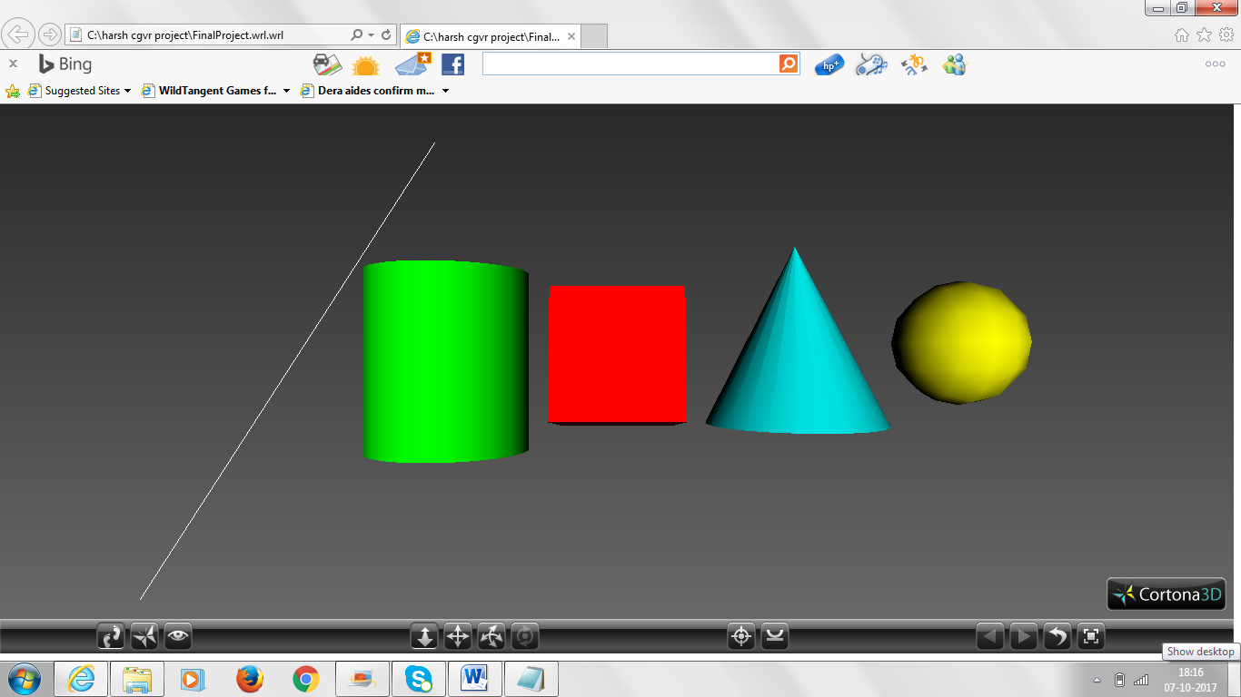

**Conclusion:-** We have successfully made our VRML project i.e to display basic Graphic primitives (shapes) in VRML modelling Language with Cortona 3D plugin viewer.